TREES

What is a Tree?
A Tree is a non-linear data structure that represents a hierarchical relationship among elements.
- It is made of nodes connected by edges.
- The topmost node is called the root.
- Each node can have children, and nodes with no children are called leaves.

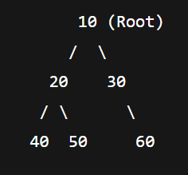

Where are Trees Used?
Trees are widely used in:
- Databases → B-trees, B+ trees for indexing.
- Operating Systems → File directory structure.
- Compilers → Abstract Syntax Trees (AST).
- Networking → Routing tables.
- Artificial Intelligence → Decision Trees, Game Trees.
- Search & Sorting → Binary Search Trees, Heaps.

Common Use Cases
- Binary Search Tree (BST): Searching, insertion, deletion in O(log n).
- Heap: Priority Queue implementation.
- Trie: Efficient prefix-based searching (e.g., autocomplete).
- Segment Tree: Range queries (sum, min, max).
- Balanced Trees (AVL, Red-Black): Keep searching efficient by avoiding skewed trees.

How is it Implemented in Java?
Node Class
class Node {
int data;
Node left, right;

public Node(int data) {
this.data = data;
left = right = null;
}
}

Preorder – Inorder – Postorder traversals

class Node
{
int data;
Node left, right;

public Node(int data)
{
this.data = data;
left = right = null;
}
}

public class TreeExample
{
Node root;
public TreeExample()
{
root = null;
}

void preorder(Node node)
{
if(node == null)
{
return;
}
System.out.print(node.data + " ");
preorder(node.left);
preorder(node.right);
}

void inorder(Node node)
{
if(node == null)
{
return;
}
preorder(node.left);
System.out.print(node.data + " ");
preorder(node.right);
}

void postorder(Node node)
{
if(node == null)
{
return;
}
preorder(node.left);
preorder(node.right);
System.out.print(node.data + " ");
}

public static void main(String[] args)
{
TreeExample tree = new TreeExample();
tree.root = new Node(10);

tree.root.left = new Node(20);
tree.root.right = new Node(30);

tree.root.left.left = new Node(40);
tree.root.left.right = new Node(50);

tree.root.right.left = new Node(60);
tree.root.right.right = new Node(70);

System.out.println("Tree created successfully");

System.out.println("Pre-order Traversals:");
tree.preorder(tree.root);

System.out.println();

System.out.println("In-order Traversals:");
tree.inorder(tree.root);

System.out.println();

System.out.println("Post-order Traversals:");
tree.postorder(tree.root);
}
}

Height of the tree
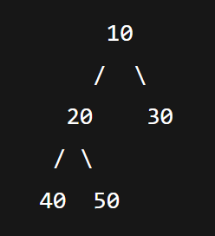

class HeightOfTree {
Node root;

int height(Node node) {
if (node == null) return 0;
int leftHeight = height(node.left);
int rightHeight = height(node.right);
return Math.max(leftHeight, rightHeight) + 1;
}

public static void main(String[] args) {
HeightOfTree tree = new HeightOfTree();
tree.root = new Node(10);
tree.root.left = new Node(20);
tree.root.right = new Node(30);
tree.root.left.left = new Node(40);
tree.root.left.right = new Node(50);

System.out.println("Height of Tree: " + tree.height(tree.root));
}
}

Output: Height of Tree: 3

Count the number of nodes
class CountNodes {
Node root;

int count(Node node) {
if (node == null) return 0;
return 1 + count(node.left) + count(node.right);
}

public static void main(String[] args) {
CountNodes tree = new CountNodes();
tree.root = new Node(10);
tree.root.left = new Node(20);
tree.root.right = new Node(30);
tree.root.left.left = new Node(40);
tree.root.left.right = new Node(50);

System.out.println("Total Nodes: " + tree.count(tree.root));
}
}
Output:
Total Nodes: 5

Search an element in Binary tree
class SearchInTree {
Node root;

boolean search(Node node, int key) {
if (node == null) return false;
if (node.data == key) return true;
return search(node.left, key) || search(node.right, key);
}

public static void main(String[] args) {
SearchInTree tree = new SearchInTree();
tree.root = new Node(10);
tree.root.left = new Node(20);
tree.root.right = new Node(30);

System.out.println("Is 20 present? " + tree.search(tree.root, 20));
System.out.println("Is 50 present? " + tree.search(tree.root, 50));
}
}

Output:
Is 20 present? true
Is 50 present? False

BINARY SEARCH TREE

What is a BST?
A Binary Search Tree is a special type of binary tree where:
- The left subtree of a node contains only nodes with values less than the node’s key.
- The right subtree contains only nodes with values greater than the node’s key.
- Both left and right subtrees must also be BSTs.

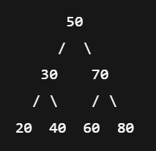

Left side < 50
Right side > 50

Why use BST?
- Searching, Insertion, Deletion → O(log n) (if tree is balanced).
- Faster than arrays and linked lists for search.
- Used in Databases, Symbol tables, Sets, Maps, etc.

